Enrolling your child
Children can participate in a kindergarten program in the year before they start Prep. This means children will be at least four years old by 30 June that year (see table below).
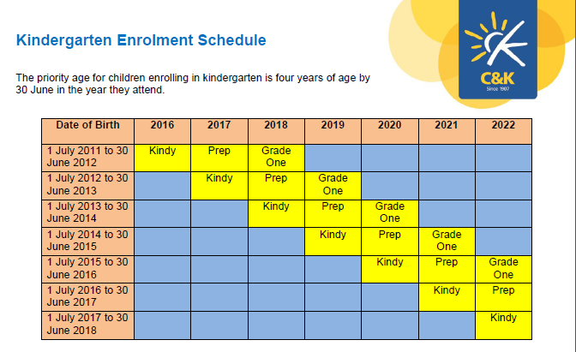

We are happy to add your child to the waiting list before they are old enough to attend. Simply complete the Waiting List Application Form located on this web-site and email it to the Centre together with $11.00 (per child) to place your child/children’s name/s on the waiting list.

Enrolments take place in the year before your child is due to attend Kindergarten so it is important to have your child’s name on the waiting list to avoid disappointment.

You are welcome to visit the Centre any day except Wednesday and between the hours of 9.00am 12.00pm.

