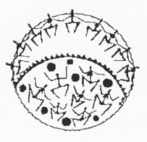

NAPRANUM
Early Childhood Centre




Alandhak Room ( 3 – 3 ½ Year olds)
(Barramundi)
Kyembal Room (3 ½ - 4 ½ Year olds)
(Crocodile)
Thungganh Room (4 ½ - 5 ½ Year olds)
(Flying Fish)

Parent Handbook
2020

Table of Contents
Welcome Letter…………………………………………………………….……………………………………...……………….3
- History………………………………………………..……………….………………………………………………..…….4
1.1 Napranum Early Childhood Philosophy……………………………....……………………………………….………………5/6
1.2 Operating Times…………………………………………………………………………………………….…………..……...7
1.3 Term Dates for Alandhak, Kyembal and Thungganh…………………………………………………………………..………7
1.4 Centre closure…………………………………………………………………………………………………………………..7
1.5 Holidays………………………………………………………………………………….……………………………..………8
1.6 Enrolment Procedures…………………………………………………………………………………..……….……………8
1.7 Waiting list……………………………………………………………………………………………....…………………...8
1.8 Priority for allocating places…………………………………………………………………………..……………………..8/9
1.9 Application packet……………………………………………………………………………………………………………9
1.10 Fee schedule……………………………………………………………………………………………………………...…9/10
2.0 Payment of fees………………………………………………………………………………………………………...……11
2.1 Late fee………………………………………………………………………………………………………………………11
2.2 Withdrawal……………………………………………………………………………………………………………..……11
2.3 Attendance……………………………………………………………………………………………………………………12
2.4 Absentee……………………………………...………………………………………………………………………………12
2.5 Absentee And Child Care Benefit……………………………………………………………………………………………12
2.6 Centre drop off and pick up………………………………………………………………………………….…………........12
2.7 Staffing…………………………………………………………………………………..…………………..………….........13
2.8 General Information…………………………………………………………………………………………….…..………..13/14
2.9 Environment…………………………………………………………………………..……………………….……………..13
2.10 Centre access……………………………………………………….……………………………………….………………14
3.0 Open door policy………………………………………………………………………………………………………….….14
3.1 Inclusion Policy………………………………………………………………………………………………………………14
3.2 Teacher/ Child ratio………………………………………………………………………………………….……………….14
3.3 Parent/ teacher communication……………………………………… ………………………………………………………15
3.4 Parent involvement……………………………………………………………………………………………………….…..15
3.5 Parental rights and responsibilities…………………………………………………………………………...…………........15/16
3.6 Notice board and notes……………………………………………………………………………………………………….16
3.7 Health and hygiene…………………………………………………………………………………………………………...16
3.8 Food and nutrition……………………………………………………………………………………………………………16
3.9 Meals and snacks………………………………………………………………………………………………………….….17
3.10 Disposal of food scraps……………………………………………………………………………………………………..17
4.0 Health and safety……………………………………………………………………………………………………………..17
4.1 Fire safety…………………………………………………………………………………………………………………….17
4.2 Sick policy…………………………………………………………………………………………………………………....18
4.3 Medication authorization form……………………………………………………………………………………………….18/19
4.4 Incident/ accident reports…………………………………………………………………………………..…………………19
4.5 Emergency Procedures………………………………………………………………………………………...……………..19
4.6 Social development and behavior…………………………………………………………………………………………….20
4.7 Consistency is the key……………………………………………………………………………………..…………………20/21
4.8 Suspected child abuse………………………………………………………………………………...………………………21
4.9 Program………………………………………………………………………………………………………………………21
4.10 Rest time………………………………………………………………………………………………....………………….22
5.0 Sun protection………………………………………………………………………………………...………………………22/23
5.1 Daily requirements…………………………………………………………………………..……………………...………...23
5.2 signing in………………………………………………………………………………………………………….………….23
5.3 sick and away days……………………………………………………………………….…………………………………..23
5.4 Immunisations………………………………………………………………………………………………………………..23
5.5 Birthdays……………………………………………………………………………………………………………………..23
5.6 Starting your child at the centre…………………………………………………………...…………………………………23/24
5.7 settling in information…………………………………………………………………………………………………………24
5.8 Outing and excursions……………………………………………………………………………………...…………………25/26
5.9 Staff professional development……………………………………………….……………………..……………………….26
5.10 Student and volunteers…………………………………………………….………………………….……………………..26/27
6.0 Confidentiality and privacy……………………………………………….…………………………………………………..27
6.1 Approved service……………………….……………………….………………………………………………..…………..27/28
6.2 Dealing with concerns ……………………………………………………………………………………………………….28/29
WELCOMING LETTER

Hello and welcome to the Napranum Early Childhood Centre. We welcome all our families and look forward to having a fun-filled year, full of memorable moments!

At the Napranum Early Childhood Centre, our aim is to provide a safe, secure & loving environment for your child. We believe that for a child to develop to their full potential they must trust the teachers looking after them. A part of this trust is built on the bonds and attachment they develop with the teachers in the room.

We endeavour to provide consistency for your child by following the routine you have at home and the care practices you use. We believe the only way to do this is to develop strong relationships with the families.

Open lines of communication, is of high importance; the information that you provide us and the little things that you tell us about your child, helps us in giving them the best possible care.

- History

Our Centre has been operating as a community kindergarten and preschool for approximately 43 years. We are affiliated with the Crèche and Kindergarten Association of Queensland.

Affiliation with C&K indicates that a centre has reached prescribed high standards in relation to buildings and facilities, safety, qualifications of staff and delivery of educational curricula. This also enables us to access funding from Education Queensland which covers approximately 80% of staff salaries.

Napranum Early Childhood Centre is an approved service and operated by the Napranum Aboriginal Shire Council.

In June 2013 the Napranum Preschool and Kindergarten and the ‘old Daycare’ was given a new name “The Napranum Early Childhood Centre as the words preschool and daycare are no longer used in the National legislation.

1.1 Napranum Early Childhood Centre Philosophy

At Napranum Early Childhood Centre, we pride ourselves in acknowledging and respecting culture, background and history of each individual child and their families and ensuring that each of these individual needs are respected and considered in all aspects of our service.

We believe children learn best through play and need to develop understanding and respect for themselves and others.
Our staff are working to achieve this by;
- Providing age and developmentally appropriate materials.
- Ensuring we have a stimulating and responsive indoor and outdoor environment.
- Facilitating learning about our community and the surroundings through excursions and discussions.
- Providing a safe and secure environment that offers acceptable challenge and risk in play.
- Role modelling respectful behaviour.
- Promoting children’s confidence; resilience; sense of wellbeing and Identity within a stimulating, rich responsive environment.
- Acknowledging each child as an individual.
- Allowing each child to complete activities at their own pace.
- Ensuring that the children develop a sense of being, becoming and belonging within the immediate environment and the wider community

We believe families are a child’s first place of learning and are critically important in the education of their children.
Our staff are working to achieve this by;
- Encouraging and supporting parents in their role.
- Involving and respecting parents’ ideas when planning.
- Acknowledging parents are an important source of information about each child’s needs.
- Ensuring parents always feel welcome to spend time with their child at Napranum Early Childhood Centre

We believe staffs are an integral link in the successful partnership of a child’s development and education.
Our staff are working to achieve this by;
- Ensuring each staff’s skills and ability are acknowledged and supported through a range of specific professional development activities.
- Working together to share ideas and support each other.
- Acknowledge and recognise duty of care towards the children at Napranum Early Childhood Centre

We believe the community are important partners, with parents and staff, in promoting the wellbeing of children at Napranum Early Childhood Centre.

Our staff are working to achieve this by;
- Encouraging involvement and support of community in all areas of the Napranum Early Childhood Centre actively liaising with organisations in the community to maintain community involvement.

We acknowledge and pay our respect to the traditional custodians of the land, the Algnith People, on whose land the Napranum Early Childhood Centre is placed.
We acknowledge and pay respect to our Ancestors and Elders past, present and future

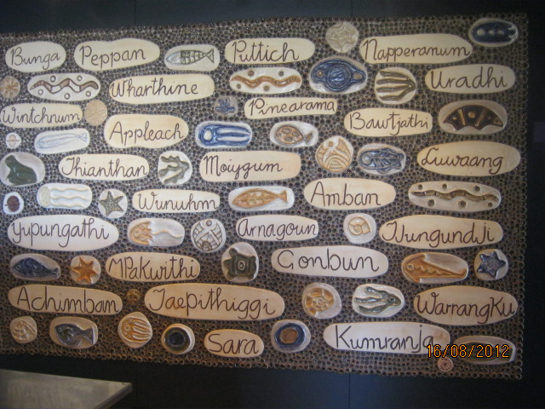
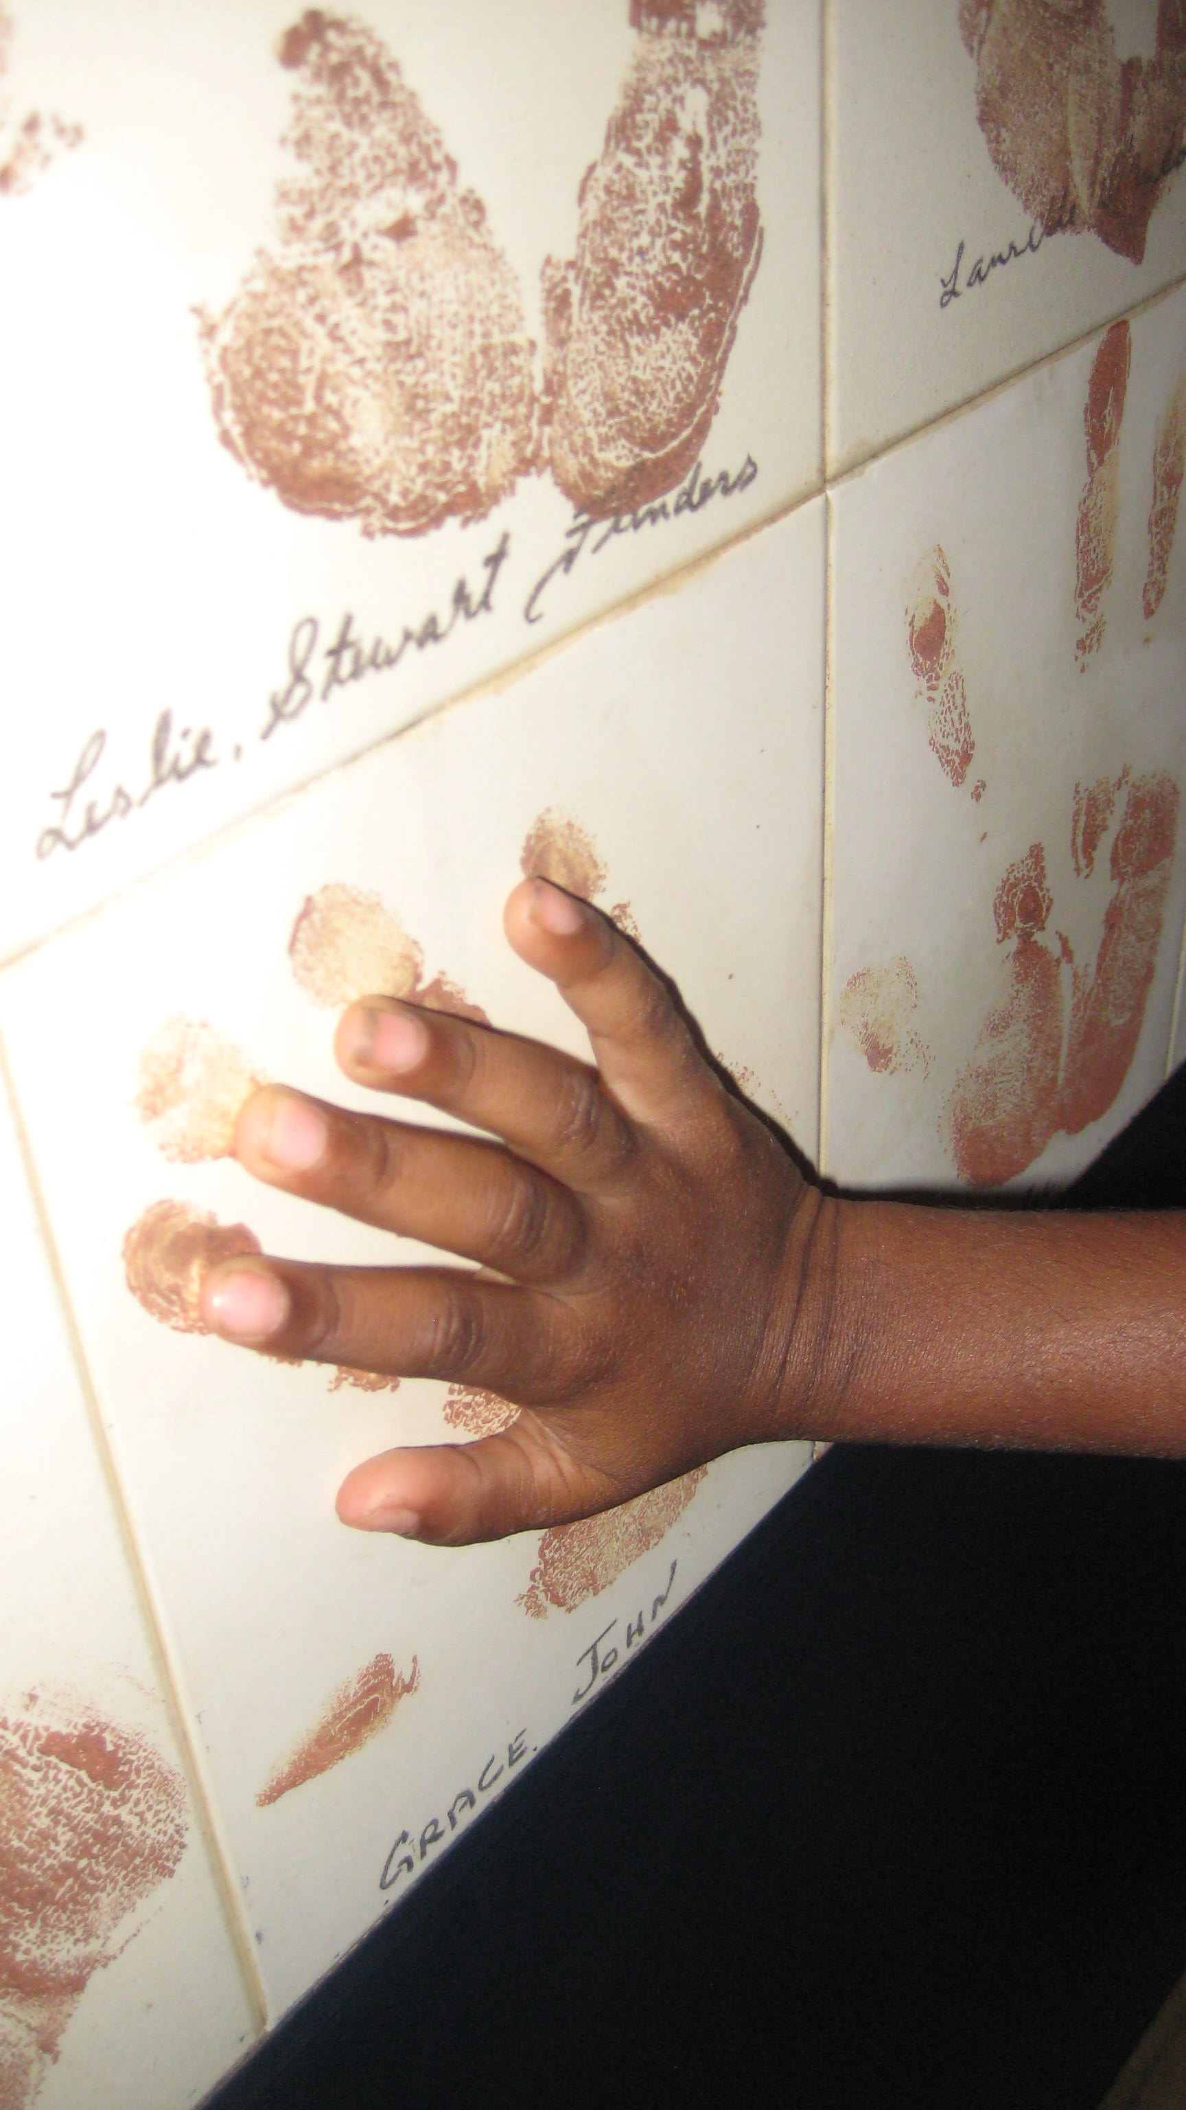

1.2 Operating Hours

The Napranum Early Childhood Centre is approved to operate under the following hours:
Room | Days | Times
Thungganh Room | Monday -Friday | 8:30am – 2.30pm
Kyembal Room | Monday -Friday | 8:30am – 2.30pm
Alandhak Room | Monday -Friday | 8:30am – 2.30pm

We are approved to cater to children between these hours. We will NOT accept any child before 8:30 am (Alandhak and Kyembal). Our staff may arrive prior to 7:30 am to prepare for the day; however we begin caring for the children at the above times. Parents and Care givers must NOT leave any child in a room unattended by staff and must NOT drop children off prior to the nominated times.

All children are to be collected by 2:30 am (Alandhak, Kyembal)
Failure to do so will result in a Late Collection Fee. (See Late and Non Collection of Children Policy and Procedures)

1.3 Term Dates - Kyembal, and Alandhak Rooms

2020 Queensland term dates
Term | Date | Length
Term 1 | Tuesday 28 January–Friday 3 April | 10 weeks
Term 2 | Monday 20 April–Friday 26 June | 10 weeks
Term 3 | Monday 13 July–Friday 18 September | 10 weeks
Term 4 | Tuesday 6 October–Friday 11 December | 10 weeks

1.4 Centre Closure

The centre will be closed for the following days
- Staff Professional Development
- Public Holidays
- Funeral in the Napranum Community
- Water and power outages that go beyond 10:00am or is off longer than two hours (as this becomes a health and safety issue)

1.5 Holidays

The Napranum Early Childhood Centre observes the following holidays each year during which the centre will be closed:
- New Year’s Day  - Good Friday  - Easter Monday  - Labour Day  - Anzac Day | - Queen’s Birthday  - Napranum Dogit Day  - Christmas Day  - Boxing Day
Full Fees will apply during holidays for when the Yarr Room is closed.

1.6 Enrolment Procedures

Parents are required to fill in a waiting list form for any child to become enrolled at the Napranum Early Childhood Centre before receiving an enrolment packet.

Once a spot becomes available in the Kyembal and Alandhak room the Nominated Supervisor will notify the parents for an enrolment packet to be completed.

An enrolment fee of $30.00 is required when registering a child at the Napranum Early Childhood Centre. The enrolment fee must be paid directly to the service before any child can start. Your enrolment fee covers a hat on arrival, beddings and library bag for preschool section and your child’s portfolio.

1.7 Waiting List

A child may be placed on the waiting list for the Alandhak room for children turning three years before the 30th June. A $10 fee will be charged to parents

1.9 Application Packet

Once a parent or guardian accepts a placement at Napranum Early Childhood Centre, he/she will be given a parent handbook and enrolment booklet. The following will be included in the enrolment booklet; Changes to this information must be updated immediately.
• Immunization record: An up to date shot record must be maintained at all times.
• Emergency Information: lets the center know who should be contacted in the event of an emergency. It lists the child’s physician, dentist, as well as other pertinent information, which would be needed if an emergency should occur.
• Travel Authorisation is required to be completed for each child. This form gives us permission to take your child out of the building for field trips, as well as for emergency situations.

Advanced Payments of Fees
Before commencement, Parents enrolling children into the Preschool section are required to pay four week of the full fee, this being $200. Your advanced payment of fees must be paid before starting preschool. This is to allow parents to always be two weeks ahead of your fees.

1.10 Fee Schedule

The income for the Kyembal and Alandhak room is generated from two sources only:

- Funding from the State Government (80% of teaching staff wages)
- Fees

Fees for 2020 for the Kyembal and Alandhak rooms are $50.00 per child, per week

Your fees for the, Kyembal and Alandhak room cover:
- Food and drinks for the children
- less than 20% of teaching staff wages
- the Centre’s operating costs
- upgrading and maintaining our high standard of facilities
- replacement of or purchase of new equipment
- maintaining the grounds and building
- materials used every day by the children, e.g. Paint, paper, pens, collage material etc.

- Payment of Fees

Fees for the Kyembal and Alandhak rooms will be invoiced at the beginning of each term. Payment is due within fourteen (14) days of receipt of an invoice.

Payment for children in the Kyembal and Alandhak room can be:

- Deposited directly to Napranum Preschool and Kindergarten bank account at the Qld Country Credit Union, BSB No. 704 640 A/c No. 41467860. Please send the remittance back so we know the account has been paid directly to our bank account. Use your child’s name as reference so the accounts department can identify your payment.

- Through Centre-Pay deductions. Forms for Centre-Pay deductions are held at the Centre.

The following procedure will be followed in response to late fees:

- A friendly reminder note will be given to you if payment has not been received within seven (7) days of the due date, or you have not contacted a staff member that you have not been able to pay by the due date.

- If payment has still not been received within a further seven (7) days, a formal reminder notice will be issued to parents/ guardians.

- If payment is still not forthcoming within seven (7) days of the issue of the former reminder, and the Nominated Supervisor has received no written explanation for late payment, suspension of enrolment will be enacted.

If for any reason you have difficulty paying the full amount by the due date, please contact the Nominated Supervisor regarding an arrangement for payment. This will be in confidence.

  - Late Fee

Late Pick-up Fees for All Rooms

First time late pick-up:
• $30 per family after the first 5 minutes and up to 15 minutes.
• $30 per family for every additional 15 minutes.
Second and subsequent instances in a calendar year:
• $30 per family for the first 5 minutes up to 15 minutes.
• $30 per family for every additional 15 minutes.

In all instances:
Late Pick-up
• The Nominated Supervisor will speak to the family and remind them of the Napranum Early Childhood Centre Late and Non-Collection of Children Policy.

Continued Late Pick-up
• If late pick-up occurs three times in a calendar year, the Nominated Supervisor will send a letter reminding the family of the Napranum Early Childhood Centre Late and Non Collection of Children Policy.
• If a fourth late pick-up is recorded, the family will be asked to meet with the Nominated Supervisor/Council and a possible termination of their child’s enrolment may occur, as the family is in breach of their enrolment contract.

Please make every possible effort to arrive each day prior 2:30 pm (Alandhak and Kyembal Rooms)
2.2 Withdrawal

Should it become necessary for you to withdraw your child from The Napranum Early Childhood Centre, a two week written notice will be required. All parents will be charged two weeks of fees at the time the written notice is received by Administratin. If you choose to leave prior to the conclusion of your two week notice, full payment is still due. Please be advised that if you withdraw your child from care for a short period of time that we cannot guarantee your child will have a spot in the future.

In the event that either the parent or child does not show the ability to conform to the rules and regulations of The Napranum Early Childhood Centre, we will require the parent to withdraw his/her child from the centre. This measure will only be necessary after reasonable efforts have been made to correct the situation. The Napranum Early Childhood Centre may give you a two week notice to find alternative care, unless the situation which has occurred becomes harmful to your child or to others. The Napranum Early Childhood Centre reserves the right to have a child withdrawn from the program immediately.

2.3 Attendance

In order for your child to fully benefit from our curriculum and daily activities, it is important for your child to attend on a daily basis. If your child will be absent, we ask that parents call the centre so that the teachers may be made aware of the situation.

2.4 Absentee

Please notify the centre if your child will not be attending for any specified time. Full fee is still required for the week.

2.6 Centre Drop Off and Pick Up
Parents are to bring their child into the building and sign them in at the Parent Station. Parent can then take their child to the appropriate room or as directed by staff on hallway duty. Children MUST NOT be dropped off at the entrance of the building and left to enter on their own. Parents are to escort their child to the room and be sure that the caregiver is aware that the child has arrived. An ADULT must bring in and pick up each child daily. Children are NOT to be dropped off prior 8:30 am.

If someone other than the parent is going to pick up the child, the centre must be notified in writing or by phone. The party picking up the child must show valid identification before the child will be released.

2.7 Staffing

All staff names and qualifications are displayed in the foyer at the entrance of the building.

The quality of care your child receives at The Napranum Early Childhood Centre is a direct reflection of its staff. The Napranum Aboriginal Shire Council will only employ staff, who are genuinely committed to providing quality care. Our staff, are dedicated to promoting the physical, intellectual, social and emotional growth of your child. Please bring any concerns you may have about our caregivers to the Nominated Supervisors attention.

2.8 General Information

2.9 Environment

This Centre actively promotes conservation and encourages children and families to protect their environment. Native animals and insects are treated with care and respect and are allowed to remain free while appropriate observation for children’s information is made. Care of the environment is fostered amongst children and adults.

The use of fresh food is promoted for lunch and morning teas to reduce the overuse of packaging. This is a conservation issue as well as a nutritional one. Pest control is carried out annually during vacation times.

2.10 Centre Access

Access to the Napranum Early Childhood Centre is through the front gates of the main building. Our parking lot can be a very busy area, especially at drop off and pick up times. To ensure your safety, as well as your child’s safety, we ask that you adhere to the following practices:

1. Please pull your vehicle into a parking space.
2. Be sure to escort your child to and from the vehicle.
3. Do not allow your child to run through the parking lot.
4. Never leave children unattended in any vehicle.

3.0 Open Door Policy
Napranum Early Childhood Centre has an ‘Open Door Policy’ where parents and family are free to come at any time of the day to collect, visit or spend time with their child/ren. As a parent you are welcome at the Napranum Early Childhood Centre at any time. We do not mind you visiting your child at any time during the day. Please keep in mind that some children have a hard time adjusting to another separation during the day. We all have your child’s best interest at heart and certainly do not want to expose your child to any unnecessary anxiety during the day. You are also welcome to call during the day to check on your child. Please be advised that it is not always possible for your child’s teacher to leave the room to speak with you on the phone, but will be given the opportunity to return your call during quiet-time if necessary.

3.1 Inclusion Policy
When children enter an early childhood setting, whether a child care setting, kindergarten or preschool, they bring with them a rich variety of cultural and social backgrounds and experiences. This Centre recognises the individuality of each child and family and observes a policy of acceptance regardless of race, creed, political or religious persuasion, gender, disability, class or culture. Individual children’s needs are identified and catered for in order for all children to gain the maximum benefit from the environment and program. Children are encouraged to recognise and celebrate differences between individuals.

3.2 Teacher/Child Ratio’s
Yarr Room – 1 adult to 4 babies (0-2 years) and 1 adult to 5 toddlers (from 24 months to 35 months)
Thungganh Room Prep Room – 1 adult to 8 children or 2 Adults to 16 Children
Kyembal Room – 1 Adult to 11 children or 2 Adults to 22 Children or 3 Adults to 25
Alandhak Room– 1 Adult to 11 Children or 2 Adults to 22 Children or 3 Adults to 24

Outside (Yard): 1 Adult to 11 Children (Kyembal, Thungganh and Alandhak rooms only)

3.3 Parent / Teacher Communication
Our aim is to foster a relationship with you and your child. Strong partnerships with families contribute to the development and well being of the child. Partnerships are strengthened when partners communicate their expectations, achievements and share a common goal. The link between parents and teachers helps to meet the needs and interests of the children and it is our hope that together we can communicate these aspects of the child. All information on the infants daily routines are recorded and communicated to parents. All nappy changes, sleep times and meals are recorded and available for parents to read. Other methods of communicating with parents are through the notice boards and notes home to parents. If you ever have any questions or concerns about the centre, the way it is run, Education and Care Services National Law Act 2010 etc., please feel free to talk to staff or the director.

3.4 Parent Involvement
Parents are welcome at any time to spend time in the room with their child. It is a great opportunity for parents to see how our day runs in the Yarr room as well as being able to spend time with your infant and their friends. We understand that for some parents it is difficult to spend long periods of time at the centre; however parent participation comes in many forms. It may be just sitting and reading a story before you leave, to helping serve morning tea (depending on the time you arrive). Other forms of participation include donating items for the creative areas, attending parent meetings etc.

3.5 Parental Rights and Responsibilities
Parents are encouraged to be aware of their responsibilities, including the timely provision of accurate information to assist staff in providing a safe and secure environment for the well-being of each individual child attending the centre.

Delivery and Collection of Children
- Children must be delivered and collected, or signed for on the bus by the parent/ guardian or responsible person as nominated by the parent/ guardian.

Staff must be notified of each child’s arrival prior to the accompanying adult’s departure when signing in. Punctual delivery and collection of children is expected. Parents are to notify staff of any changes to the delivery and collection times for their child.

In the event that staff have not been notified of a late collection, the following procedure will occur:
- Staff to contact parent/ guardian/ care provider
- Staff to contact the Emergency Contact Person to collect the child
- If staff can still not locate a suitable adult, staff shall inform Police, Justice group, or Child and Family services of the situation if required.
- If collection of a child occurs more than 15 minutes after the session conclusion, without prior notification, a late fee will apply.

Notification of Changes to Recorded Information
Parents are to notify the Director of any changes to:
*emergency contact names, phone numbers and address
*medical history, occurrences, requirements, immunisation records, family changes
The Centre Director will check and update all emergency information – parents’ address, phone number, work address and phone number, emergency contact persons and addresses and phone numbers and medical history every 12 months.

3.6 Notice Board & Notes
We use our Notice Board to display the centre goals, centre philosophy, the program, messages and notices. The staff put information such as weekly accounts, receipts, newsletters, notices and messages in your child’s lockers so you are kept informed on the goings on in the centre.

3.7 Health and Hygiene
High standards of health and hygiene are essential for the well-being of young children and staff at the Centre. It is important for staff and parents to be aware of health issues and steps that should be taken to prevent and reduce the spread of disease and infection. Sound health and hygiene practices modeled by adults for children will ensure that children observe and use such habits, including,
HANDWASHING:
To reduce cross-infection and contamination of toys and equipment:
- Staff and children will wash hands (with soap) prior to eating and after toileting or blowing of noses
- Children will use individual hand towels or paper towels for hand drying.

FOOD PREPARATION:
Any activity where children are assisting with food preparation, the above procedure will apply.

3.8 Food and Nutrition
“Good nutrition plays a large part in promoting a healthy, happy and alert child. Good nutrition can lead to good muscle development, regular and normal bowel actions, healthy shiny hair, clear eyes and strong teeth with healthy gums and provides plenty of energy for learning and playing” (from the Australian Nutrition Foundation Inc.).
This Centre promotes a good nutrition policy because of the resulting benefits to young children. Educating young children about healthy eating is an important part of our program and we trust that parents will also take part in our efforts to teach life-long healthy eating habits.

3.9 Meals and Snacks
All meals for children under 12 months of age MUST be provided by their Parent/Caregiver. All meals should be nutritious.
The Napranum Early Childhood Centre will provide all meals for children 12 months of age and over.
The Napranum Early Childhood Centre will provide a nutritious morning tea, lunch and afternoon tea. Children will be served family style in their eating area and will be encouraged to feed themselves and to use proper table manners. All children will be encouraged to try a variety of foods; however children are not required to eat all of the food on their plate.

Typically, morning tea will be served at 10:00 am, lunch from 11:30 am – 12:30 pm, and afternoon tea from 3:00 pm. Please be sure your child has already had breakfast.

The menu will be posted near the kitchen on a weekly basis for daily reference. Menus are planned in accordance with good health and hygiene practices. Information concerning children with food allergies is posted in both the kitchen and the child’s room. Please make staff aware of any allergies your child has.

Food substitutions are allowed only when a child is diagnosed with food allergies and a physician’s documentation is provided.

Non-nutritional (Junk) food items can only be served for special occasions and must be supplemented with nutritional food items.
3.10 Disposal of food scraps
All food scraps will be disposed of promptly and appropriately in a manner conducive to the health, hygiene and safety of children and staff at the Centre.

4.0 Health and Safety
Your child’s health and safety are our primary concern. The policies of The Napranum Early Childhood Centre regarding health and safety are in place to protect each child in our care. Our policies are designed to keep in accordance with National Quality Framework for Early Childhood Education and Care - Legislation, Standards and Progress.

4.1 Fire Safety
Fire safety equipment such as fire extinguishers, fire blankets and smoke detectors are located and fitted in the Centre. A current fire evacuation plan is displayed in the Centre, with monthly fire drills practiced with the children. This procedure provides fire safety awareness for all children attending the Centre.

4.2 Sick Policy
If your child has a temperature above 38 degrees or higher, is vomiting or has diarrhoea, we require you to keep your child home or we will contact you to come pick up your child.

We appreciate how difficult it can be for parents to take time off from work to care for a sick child, but The Napranum Early Childhood Centre does not have the facilities to care for sick children. If a child is unable to participate in the daily activities of the centre, including outside play, the child should remain home. Children are unable to be moved to an alternate room to avoid outside time.

If your child is sent home sick, he/she may NOT return to The Napranum Early Childhood Centre for a full 24 hours after the sickness/fever has subsided. For example, if your child is sent home with diarrhoea at 9AM, he/she may not return to the centre until 9 AM the next morning, provided that your child has not had any further incidents. This not only provides your child with the opportunity to become completely well again, but also protects the other children in your child’s class from becoming infected.

The following is a list of some common childhood diseases and infections. Unless marked by an asterisk, children are not permitted to return to The Napranum Early Childhood Centre unless treated by a Doctor, or symptoms are no longer apparent after twenty-four hours. This is only a partial listing, so please check with the Director if there are any questions concerning your child or other children in the classroom.

- Chicken Pox Conjunctivitis (pinkeye)  - Diarrhoea Fever of 39 or higher (with or without a rash)  - Fifth Disease Impetigo  - Scabies  - Lice  - Scarlet Fever  - Strep Throat | - Whooping Cough  - Measles  - Hand Foot and Mouth  - Thrush  - Cold  - Ringworm  - Vomiting

4.3 Medication Authorisation Form
All medicine for children enrolled in The Napranum Early Childhood Centre must have specific instructions and written permission for administering any medication. Instructions must be completed by either the child’s parent or doctor and must include:
1. Who the medicine is for
2. How much is to be given
3. What time the medicine should be given (slip cannot say “as needed”).
4. How often the medicine is to be given
5. For what length of time; medication slips are good only for a one week period of time

Prescription Medicines:
1. Must be the original container, bearing the original label
2. Must have complete instructions on the label or be accompanied by written instructions from a health professional which include 1-5 above
3. Must be administered only to the person for whom it was prescribed (Siblings may not take the same medication unless written orders from a physician are given)
4. Cannot be administered after its expiration date

Over the Counter Medicines:
All information under 1-5 of the above instructions must be followed, as well as:
1. A doctor must give instructions about dosage if the dosage conflicts with the instructions on the medicine bottle. However, a parent can write a statement that identifies the doctor who was contacted, the date the doctor was contacted and gives specific instructions about the dosage from the doctor.
2. Medicine can be kept and given to a child only for the length of time noted on the instructions, and never after its expiration date.
3. Medicine should only be left at the centre while the child needs it.

4.4 Incident/Accident Reports
Minor injuries may occur in the day-to-day activities of a child. When a child receives any bump, scrape, bruise or cut while under the care of any staff member of The Napranum Early Childhood Centre, an Incident/Accident Report must be filled out. The child’s name, date and time must be written at the top of the report. The nature of the injury will be written down and the circumstances of the accident will briefly be described on the report. The teacher will then sign the report. For injuries requiring medical attention or emergency treatment, an Incident Report form will be filled out as listed above. Please note that parents will be notified immediately (by the Director) of any incident/injury requiring medical attention.
Upon the arrival of the parent for pick up, he/she is given the report and asked to sign it. The original report is kept in the child’s file, and a copy of the report may be taken home by the parent.

4.5 Emergency Procedures
In the event of an emergency, your child will be transported to the nearest hospital. Every effort will be made to contact you for instructions prior to leaving. If you are unavailable, we will transport your child to the location most appropriate under the circumstances. The emergency form from your child’s packet will be taken with your child. A member of staff will contact the doctor or hospital to inform them of the situation and our pending arrival. We will continue to attempt to reach you to inform you of the incident/accident and where you should meet your child.

4.6 Social Development and Behavior Management
Young children will enter The Napranum Early Childhood Centre with a wide range of social skills and competencies and the program at the Centre will provide the children with experiences that further develop their personal and interpersonal skills. To facilitate the development of these skills, the children will be:
- developing their own sense of self-worth and an appreciation of the worth of others
- encouraged to learn positive behavior to ensure safety and positive group relations
- working in an environment which fosters co-operative and collaborative behavior
- developing and practicing conflict resolution strategies

Teachers must maintain control of the children at all times. Thoughtful planning and preparation will help maintain control and helps to prevent discipline problems from occurring. Activities are carefully planned to prevent children from becoming bored or having idle time on their hands. Transitional periods can also be a difficult time for children; therefore the teacher will let the children know what is expected of them ahead of time. Finding fun ways to change from one activity to another helps keep the children’s attention focused in a positive way.

Teachers will be aware of potential problems. Close observation will allow them to stop a problem before it starts. Indirect guidance will be used as a preventive measure. The environment will be arranged to prevent misbehavior. Children’s seats and places in line will be arranged so that those children who get along with each other are close together. Children who are frequently disruptive will be mixed with more cooperative children.

Direct guidance will flow as follows:
1. The desired behavior will be stated in a positive way on the first offense
2. Time out will be used on the second offense
3. The appropriate behavior will be reinforced as soon as possible after time out
Thinking Time is used when a child’s behavior becomes so disruptive that it interferes with the normal flow of activities. Thinking Time should be used as a last resort or when a child’s behavior endangers the child, classmates or environment. If a child throws or hits with an object, or bites, the child should visit the Thinking Time area immediately. Thinking Time will not be used in the Yarr room, as this is developmentally not appropriate for children in this room.
If Thinking Time must be used, the child will be seated away from the other children, but where the child can still be easily supervised. The child will be told why he/she is being placed in Thinking Time. The duration of the Thinking Time is based on the child’s age. When a child fights with objects, their attention will be redirected to something positive to divert the hostility. We will not respond to other children‘s tattling. We will only intervene when a negative behavior is observed. We will investigate the incident without making accusations.

4.7 Consistency is the Key!
We will always try to remain consistent with each child. The following steps are followed:
1. We will non-verbally discourage negative behavior.
2. We will verbally remind the child of the room rules.
3. We will reposition the child near staff, away from the distractive situation.
4. If there continues to be a problem, we will have the child sit in the Thinking Time area.

4.8 Suspected Child Abuse
It is our responsibility to care for all of the children at The Napranum Early Childhood Centre and to keep their best interest in mind at all times. Therefore, any suspected child abuse will be documented and reported to the Department of Communities Child Safety by a member of Staff.

4.9 Program
Napranum Early Childhood Centre philosophy is based on the belief that children learn through play. We base our programming around the Early Years Learning Framework, which is part of the Council of Australian Governments’ reform agenda for early childhood education and care. It is a key component of the Australian Government’s National Quality Framework for early childhood education and care. Our program also embraces Crèche and Kindergarten Association - Building Waterfalls 2 Curriculum, where we implement a learning program where play is a priority. The staff views all children as competent individuals and treats them as such. They do this by offering a program that is ‘self selective’ and ‘interest based’. This means that all equipment is on offer and children are free to choose what it is they would like to engage in. This allows staff to become engaged with the children in their play. Interactions are richer due to children being engaged in conversations of interest. The staff joins in and discover with the children all the while documenting the learning that occurs. This type of learning program encourages children to make appropriate choices and decisions, which enhance their cognitive thinking, and self esteem.

On the walls of your child’s room you will see a basic program and these experiences are offered to your child every day. The curriculum that is run is the further planning done for each child based on their interests. These interests are documented on the walls of your child’s room. You may find your child showing interest in these things at home. Please feel free to give ideas so we can extend your child’s learning.

All documentation of your child is kept in an individual portfolio of your child. These journals tell the story of your child’s time at the center and if you add to them, which we strongly encourage, it will then tell the story of your child’s life.

4.10 Rest Time
Teachers and childcare professionals believe that rest and relaxation, even for short periods, are an essential part of a full day program. Establishing a pattern of rest and relaxation, like good eating habits, are benefits which can carry into later life. After a busy time of physical and mental stimulation, rest time gives the growing child space in which to recapture vitality. A child who has learned to relax will become an adult who is able to deal more adequately with the stress and strain of normal living. Sleep is not essential. When the body’s muscles have a chance to relax completely, the child’s mind can relax completely too. Rest time is a quiet time to think, plan and relive some experience without the ‘doing’. Individual differences in rest requirements will be taken into account with quiet time activities available after a suitable rest time.

Cot Room – Yarr Room Only
The cot room is another quiet air conditioned room that is only for resting and sleeping. Infants have their own bed & sheets which they sleep in everyday they are in care for consistency. Sleeping infants are checked every 15 minutes and this is documented as well as when infants sleep and for how long. Older toddlers use mattresses which are placed on a carpet on the floor.

5.0 Sun Protection
All children and staff are to wear a hat and appropriate clothing whilst outdoors and have a broad spectrum, water resistant sunscreen (SPF30+) applied to their exposed skin prior to outdoor activity. It is recommended that sunscreen be applied twenty minutes prior to exposure to the sun. Parents are asked to apply sunscreen to their child before arriving at the centre.

Our policy is “NO HAT, NO PLAY OUTDOORS”

Legionnaire or broad-brimmed hats which protect the face, neck, ears and crown of the head are essential. Outdoor activities are generally restricted to before 11.00am.

Parents will be required to provide written approval for the application of sunscreen to their children by staff. If a child requires a specific sunscreen due to skin type, e.g. sensitive skin, parents are then requested to provide an appropriate sunscreen.

The C & K Sun Care Policy can be found in full at the centre. Please take time to read it.

5.1 Daily Requirements
Alandhak, Kyembal & Thugganh room
- 2 sets of spare clothes

Yarr room
- Comforter - that your child normally uses to get them to sleep (if needed)
- 1-2 sets of spare clothes – to be kept in your child’s bag for emergencies
- Bottles and formula and/or breast milk. Already made up and labeled with child’s name.
- A copy of your child’s routine, cues or rituals.
- (10) Disposable Nappies – enough for the whole day
- Food enough for the hours your child is at the centre (the centre caters for children over 12 months only)
- Dummy if required. Please bring dummy in small plastic container with your child’s name. Container keeps dummy’s separate in the refrigerator and are only to be used if upset and being carried by staff or for sleep. Dummies will not be used for happy children or children actively walking around.

PLEASE NAME ALL ITEMS TO PREVENT LOST PROPERTY

5.2 Signing in
Please remember to sign in and out each day, to be eligible for their childcare benefit. If your child is away, please sign and write 'Away' or 'Ill'. Both sign in and out sheets are located on top of the front desk. Names will be highlighted if not signed daily. We also require you to sign-in and out on a form used in case of an emergency, such as a fire, or in case your child is sick whilst in care. Please make you provide us with a contact number for every day your child is in care.

5.3 Sick and Away Days
When your child is not feeling well, it is best to keep them at home as they will only spread their germs and make everyone sick. We are sure you would appreciate other parents doing the same. If your child is away please ring and let us know.

5.4 Immunisations
The Napranum Early Childhood Centre strongly encourages the immunisation of children. Parents/ guardians will be required to provide information regarding the immunisation status of their child upon enrolment. A completed immunisation record will be required as an acceptable vaccination certificate. In the event of an outbreak of a vaccine preventable disease, parents/ guardians of a non-immunised child will be required to remove the child from the service until the risk has passed.

We ask that you keep your child at home on the day of their immunisation as young children are often irritable and recuperate better in their home environment.

5.5 Birthdays
We consider these very special in our room so if you'd like to bring a cake in on your child's birthday or even a little party, please notify staff beforehand as some children might have allergies to certain ingredients.

5.6 Starting Your Child at the Centre
To assist your child with a smooth “settling in” period, we suggest you both have a good look around and that you stay and join our activities for about half an hour or as long as you feel you need to. When it is time to go, please let your child know you are leaving, reassure him or her that the day will be fun and that you are coming back. After you say goodbye, it is best to leave quickly. If your child is distressed at your leaving, please feel free to telephone us when you get home or to work. In most cases the children settle down very soon and join in activities. We will make every effort to settle your child quickly. Be positive with your child when talking about his or her first visit (even if you are feeling anxious yourself).

Please note that the time before 8:30 am in the Thungganh, Kyembal and Alandhak room is used by staff for preparation for the day. There is no supervision of your child by our staff until 8:30am, so please be considerate and do not leave your children before then.
Supervision in the Yarr room will commence at 7:30am

Greet your child warmly when you return at the end of session or on the bus run, and PLEASE BE ON TIME! A few minutes is a long time for a child who is waiting for you.

It is not easy for a 0 to 5 year old to tell you all that’s happened in a day. Don’t be surprised if he or she says “nothing” when you ask about what happened at the Centre.

In your child’s world, play is very serious – very important. It is their work – a way of learning about the world. It is essential for children’s basic development in all areas (physical, emotional, social and intellectual). Please do not be disappointed if your child does not bring something home after each day. They have been working hard – with puzzles, in the sandpit, climbing, singing etc. These activities are as important as painting, collage or construction.
When your child does have work to take home, it is important that he or she sees that you are enthusiastic and approving of their work. Maybe display it for a week or two on a wall or noticeboard or involve your child in keeping their favorite pieces. Enthusiasm and approval build up your child’s self-esteem and confidence.
As children are participating in so many things and with so many people, they will arrive home exhausted from Kindergarten/ Preschool. Make this quiet time, giving your child time to either unwind, or to wake up properly in the case that he or she has been asleep during the required rest/quiet time.

5.7 Settling In Information
The settling in period for new babies and toddlers should be well planned. The ideal situation would be to have you accompany your infant to the centre and play with them whilst interacting with staff. During this time, staff concentrate on building a trust between themselves and the baby. You and your child are welcome in the room as many times as you would like for as long as you would like prior to the child's commencement so that the transition can be smoother. It is less stressful for both you and your child if they are gradually introduced to the separation. Remember saying "Goodbye" to your baby is very important and helps in the settling in period.
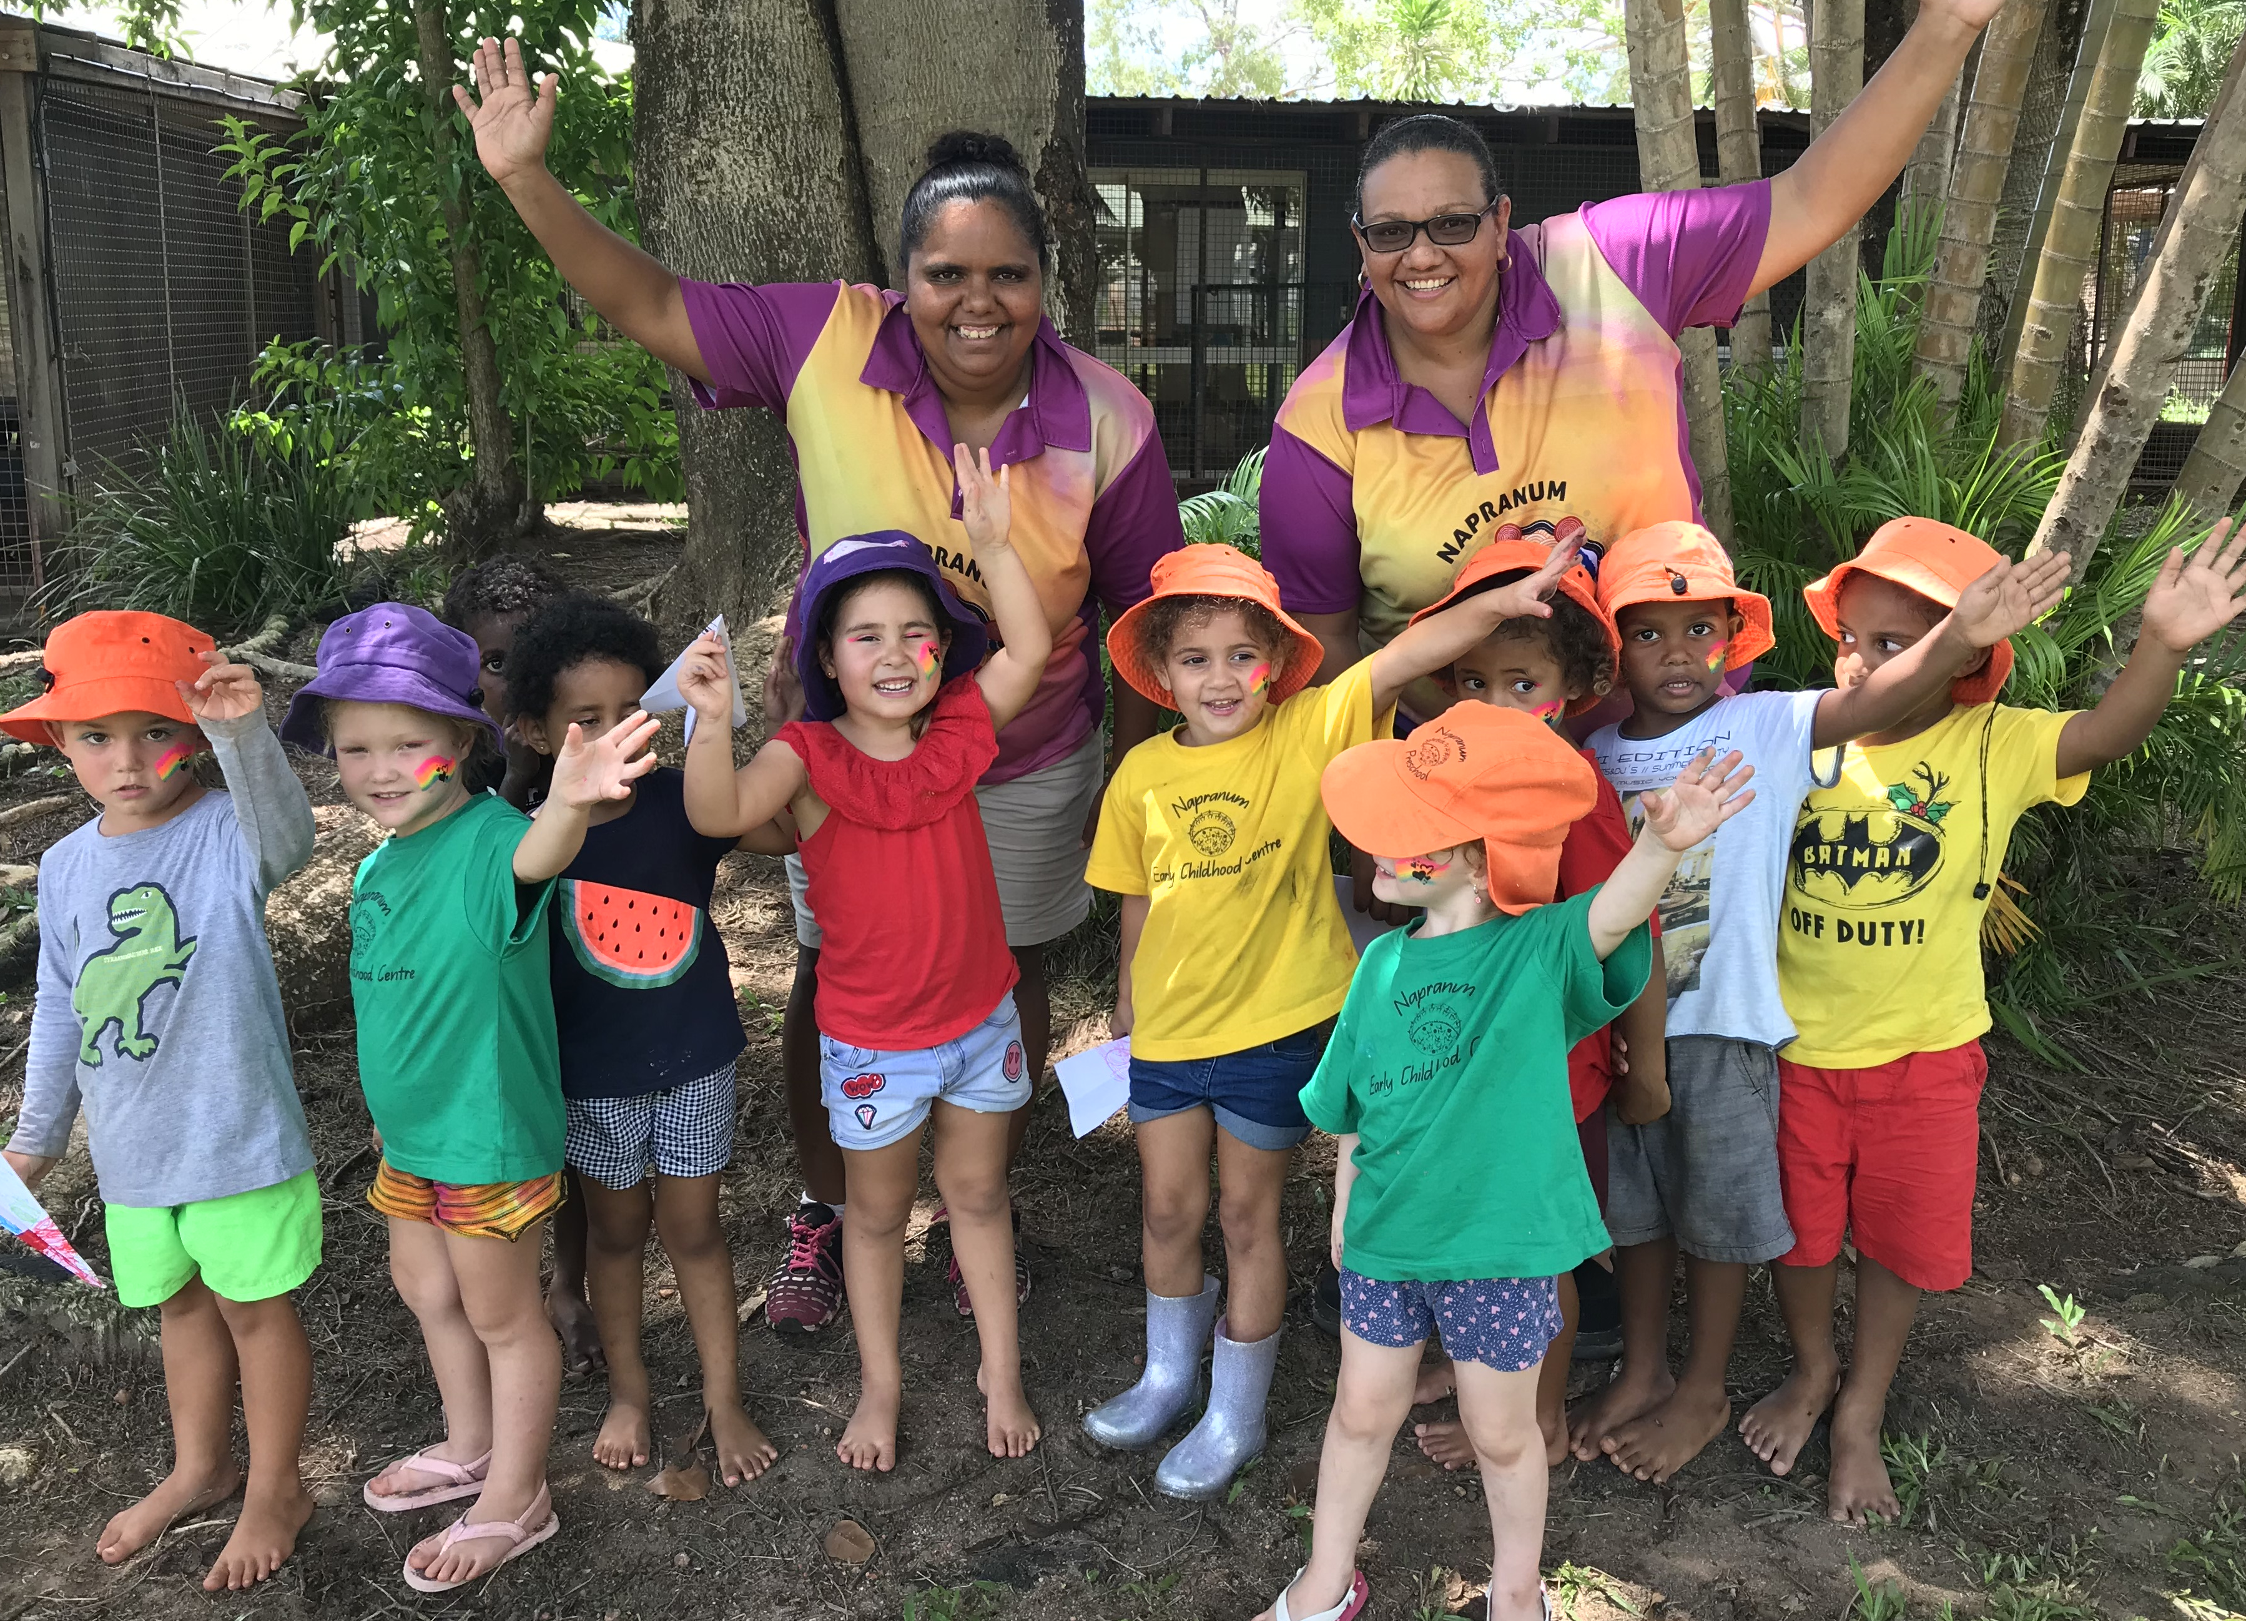
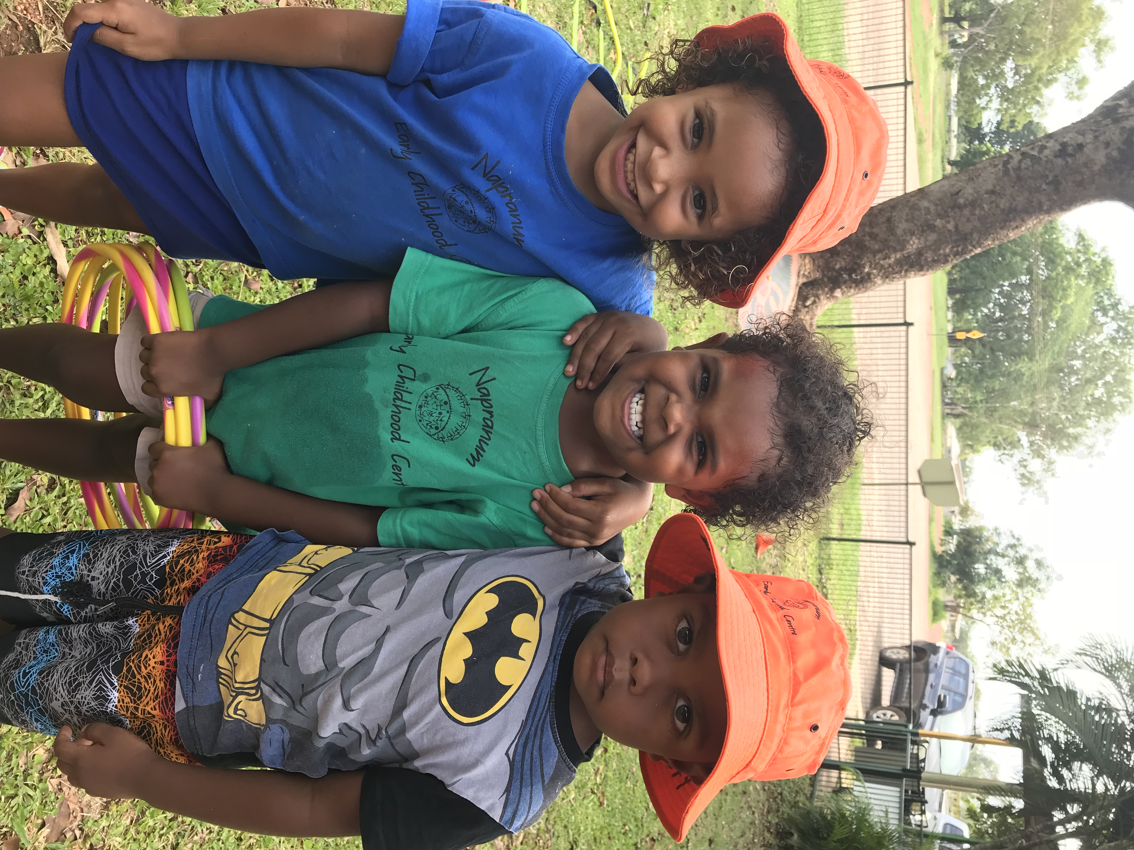


5.8 Outings and Excursions
Visits into the general community and to arts/cultural presentations hold great value for young children. Napranum and Weipa’s geographical location increases the benefits of contact with a variety of social, cultural and artistic experiences.

Excursions/ outings will be based on developmentally appropriate content, location and duration of the event. The care and safety of the children will be the primary consideration during the planning and running of an excursion.
The maximum benefit will be drawn from excursions with lead-up discussion and experiences, sufficient adult support and supervision during the event, and relevant follow-up/ programming.

With the recent trend in Early Childhood Education being about children exploring and investigating the outside world and taking risks, staff at the Napranum Early Childhood Centre will begin to imbed in the Alandhak, Kyembal and Thungganh program, a practise that will inspire the children and staff in their lifelong learning…”Going Walkabout”.
“Going Walkabout” will include various outside activities that will take the children out of the preschool grounds. Some activities might include:

- Visits to local community organisations eg: Council Office, HACC village, Workshop, PCYC
- Exploring the beach, playground, oval
- Identifying where children live – address
- Talking with elders
- Visits to Weipa
- Picking up rubbish – Clean up Napranum
- Community walks to promote good health - exercise
Research demonstrates that children learn best when they are immersed within respectful, responsive relationships, and experience learning that has relevance and meaning for them. “Going Walkabout” will help children explore their world that connects us with our past to influence, and guide and direct learning opportunities for the future. “Going Walkabout” will support our children’s rights to educational experiences that are within their own community and cultural contexts and will enable our children to build upon this knowledge to promote rich learning opportunities.

We believe that if we do all our learning within the preschool grounds we restrict our children’s play, limit their freedom of movement, possibly limit their relationships with adults and restrict their learning. We have revised our way of thinking about children and childhood, with an emphasis on nurturing children’s resilience. We want to make the creation of a child-friendly Napranum a much higher priority. By “Going Walkabout” we believe we will have a better balance between protecting children from genuine threats and giving children rich, challenging opportunities to learn and grow.

We have decided that every Thursday (weather permitting) will be our “Going Walkabout” day. Children in the Yarr Room will not be participating in this activity.
Parents please be aware that these activities in the community will include children and staff walking around the community. We ask that all children have some form of footwear on when “Going Walkabout”. All parents, caregivers and community members are most welcome to participate in “Going Walkabout”.

Parents will be notified of an excursion including date, time, location, purpose/ content and means of transport.

Children will leave the Centre under the correct ratios of staff/children depending on age group. The adults will be considered by the Director as responsible.

Permission slips must be signed by a parent/ guardian prior to departure.

If car travel is required for an excursion, the Director will ensure:
- the driver of the car is licensed
- third party insurance is current
- a separate seat belt is available for each child and adult
- a minimum of two adults per vehicle

If a bus is to be used to transport the children, parents will be notified of the availability of safety restraints.

5.9 Staff Professional Development
The Napranum Early Childhood Centre actively supports the ongoing professional development of all staff members through their attendance at courses, seminars, workshops and conferences.

All contact staff are required to hold a current senior first aid certificate and blue card.

The Early Childhood Education award requires teaching staff to participate in three days of professional development each year in their own time.

The Napranum Early Childhood Centre has a professional development budget to support staff in their advancement of professional skills and knowledge (training/ qualifications).

5.10 Students and Volunteers
We support the placement of students and volunteers in our Centre subject to their involvement not being to the detriment of the children. Students and volunteers are supervised by staff at all times. Any concerns regarding student/ volunteers in our Centre are to be discussed with the director without delay.

6.0 Confidentiality and Privacy
The Napranum Early Childhood Centre will endeavor to maintain confidentiality and to protect the privacy of all children and their families.

Upon enrolment, parents are required to sign a form indicating whether or not permission is given for their child to be photographed by the media/students/visitors or for any promotional purpose.

The C&K Confidentiality and Privacy policy can be found in full at the centre.

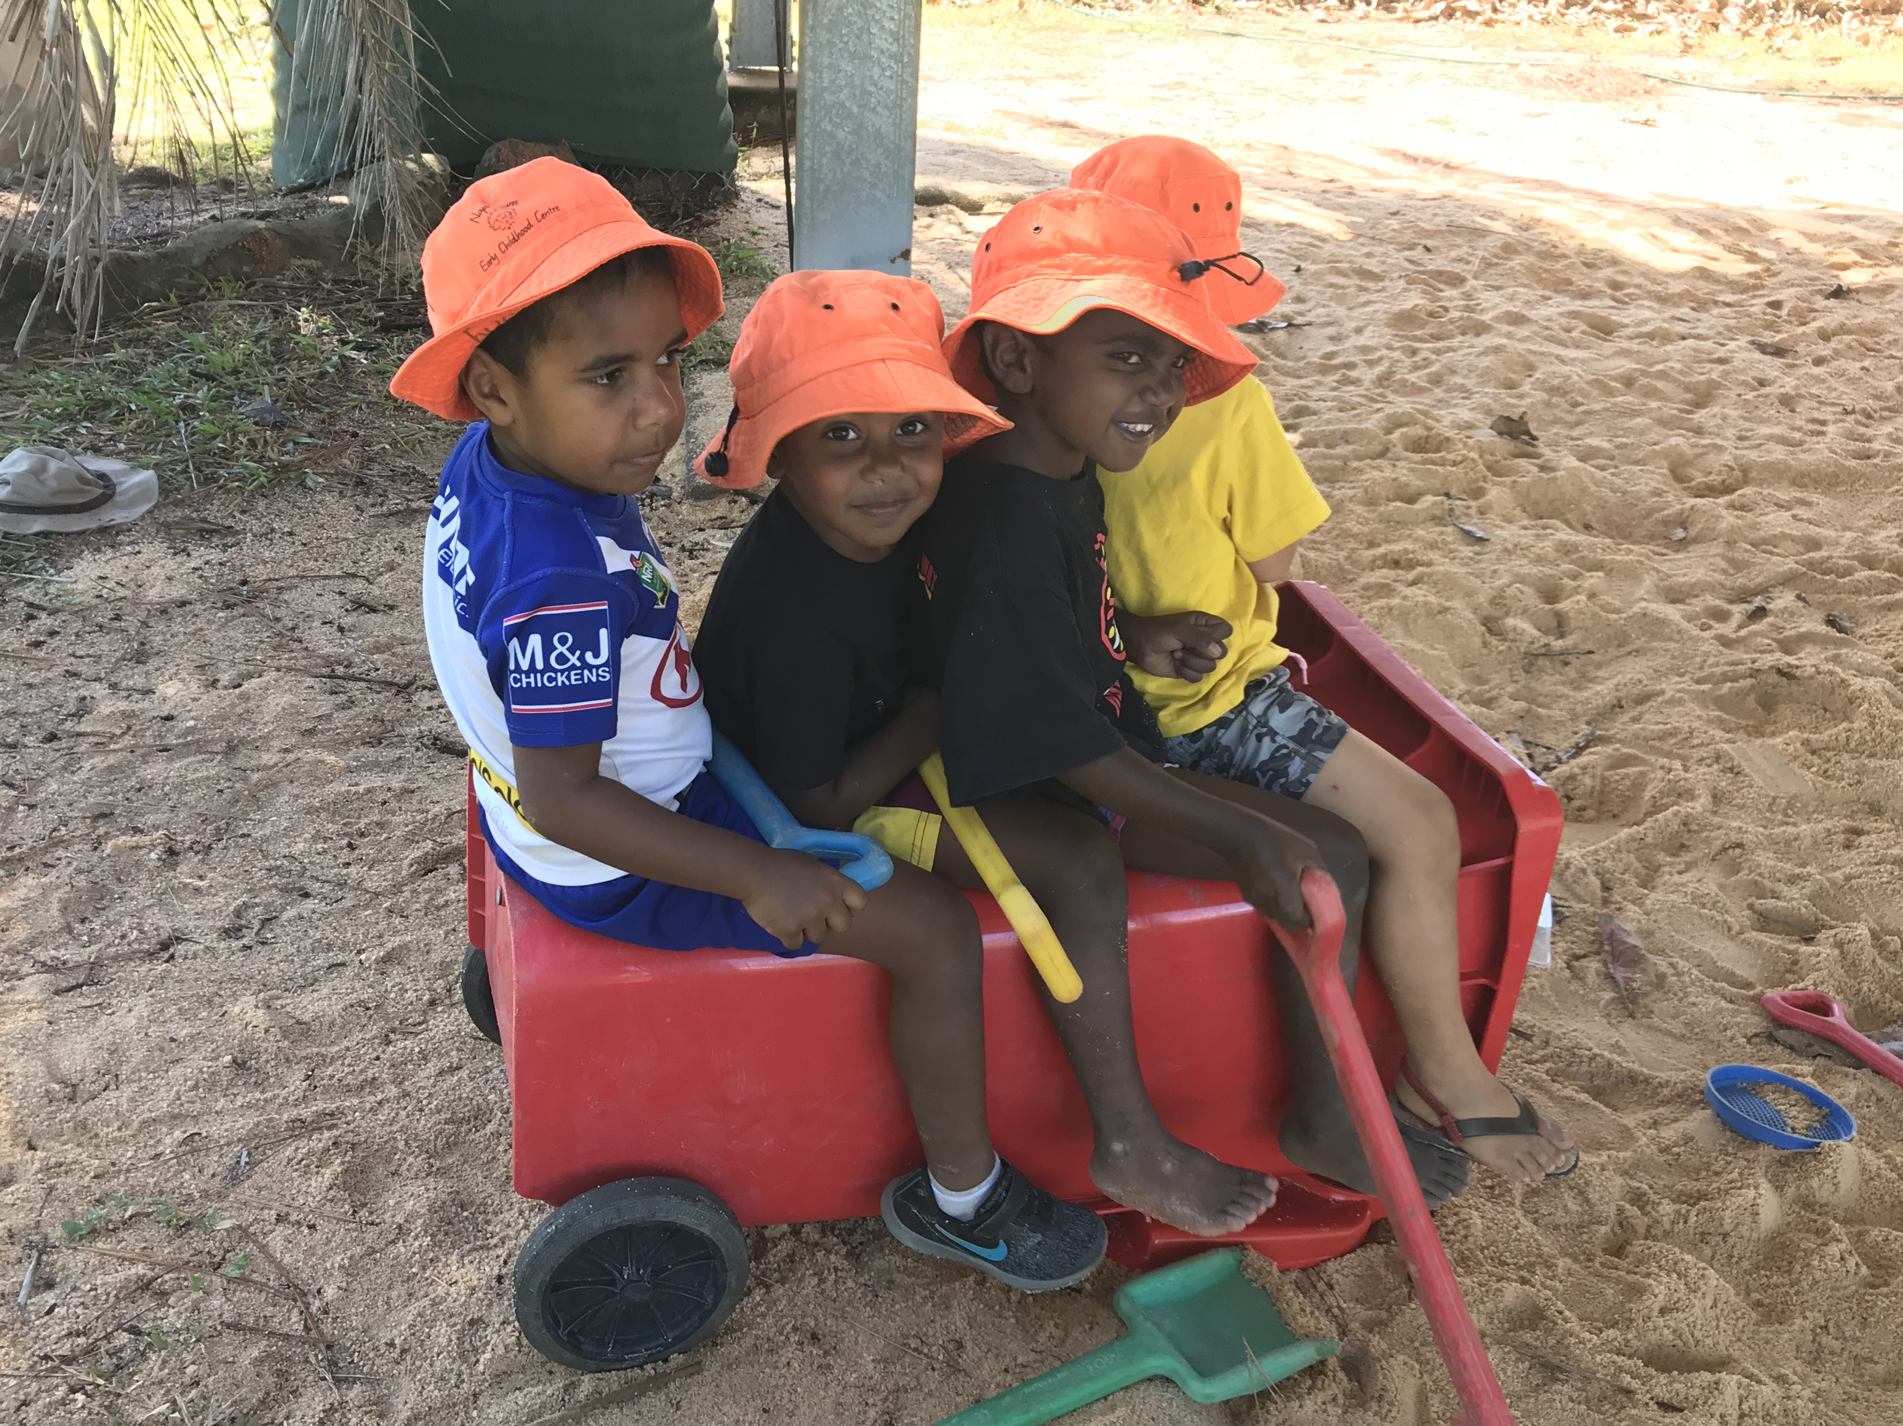

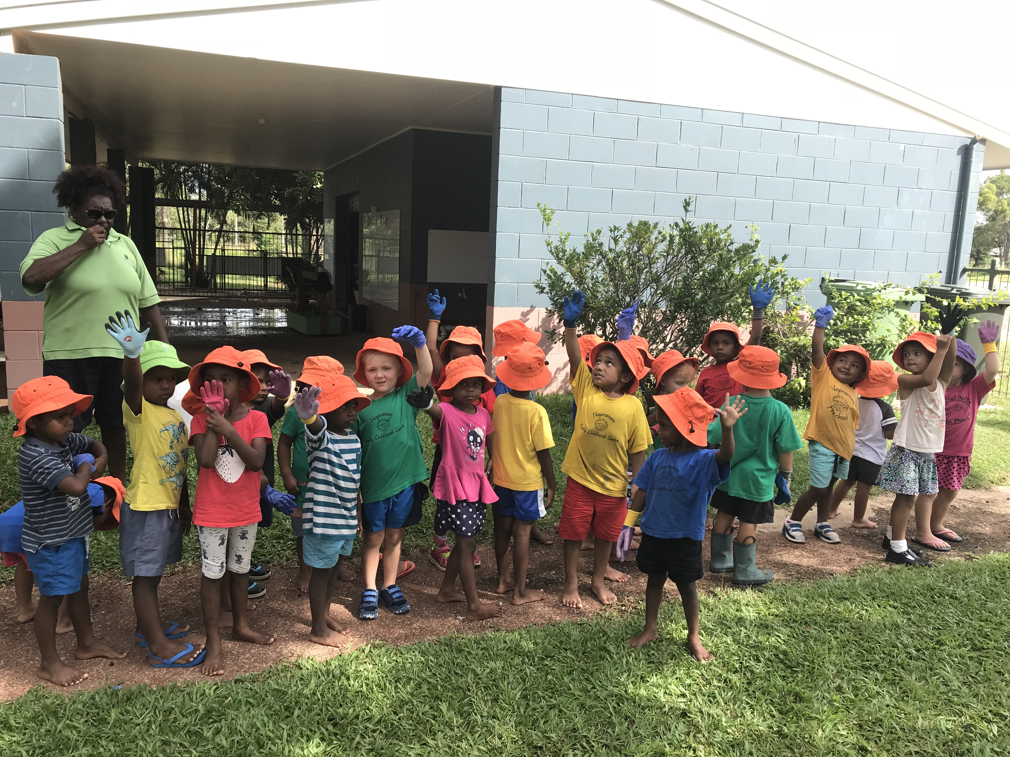

6.1 Approved Service
The Napranum Early Childhood Centre is an Approved Service under the Education and Care Services National Law Act 2010. The Australian Children’s Education and Care Quality Authority is to guide and monitor the consistent implementation of the Education and Care Services National Law including the National Quality Framework and promote quality and continuous improvement.
Contact detail for ACECQA
Ph) 1800 181 088 www.acecqa.gov.au email: enquiries@acecqa.gov.au
The Department of Education, Training and Employment is committed to ensuring Queenslanders have the education and skills they need to contribute to the economic and social development of Queensland.
The Office for Early Childhood Education and Care is responsible for:
- approving, licensing and regulating early childhood education and care services in Queensland
- funding services to support the early childhood education and care of Queensland children
- driving national early childhood education and care reforms in Queensland including:
- National Quality Framework
- Universal access to early childhood education
- Indigenous early childhood development
Telephone | Kindy Hotline  1800 4 KINDY (54639) | For information on the Queensland Government's kindergarten reforms  *Calls from mobiles charged at applicable rates.
Telephone | Early Childhood  Information Service  13 QGOV  (13 7468) | For information about a Queensland early childhood education and care service  *Calls from mobiles charged at applicable rates.
Fax | (07) 3234 0310
Postal address | Office for Early Childhood Education and Care  Department of Education, Training and Employment  PO Box 15033  CITY EAST QLD 4002
Email | ecec@dete.qld.gov.au  (please include your contact phone number in your email)

The SERVICE APPROVAL certificate for Alandhak, Kyembal and Thungganh rooms is displayed in the reception area.
The SERVICE APPROVAL certificate for Yarr room is displayed in the room entry. The Provider Approval Certificate for the Napranum Aboriginal Shire Council is displayed beside both service approval certificates.

6.2 Dealing with Concerns
Staff of Napranum Early Childhood Centre recognises the significant role of parents as a child’s first teacher and the bearer of intimate knowledge of their child. Positive home/ Centre relationships based on trust and co-operation are required to increase the benefits that the child gains from the program.

Parent’s ideas, suggestions, queries and concerns are valued and sought, with each one addressed and responded to promptly.

Parents are encouraged to speak regularly with the teacher about their child’s progress. Parents should make an appointment for a parent/ teacher interview to formally review their child’s progress. These interview programs will occur at least twice a year. Parents are also welcome to make an appointment for discussion with the teacher at any time during the year.

Where a parent has a query/ concern relating to the program, the waiting list or roll, the parent should make direct contact with the Teacher/ Director.

Where a parent has any query relating to the payment of fees or other matters relating to committee, management or administration, please contact the appropriate person.

Should a parent have further concerns following these first steps, the Crèche and Kindergarten Early Childhood Consultant may be contacted:

If you have any concerns regarding the care of your child, please approach your child’s Group Leader and discuss the matter with them. If you feel that your concerns are not being met, please do not hesitate to discuss this with the Director.
In the event that you are still not satisfied with the outcome please contact:

The Department of Education, Training and Employment Early Childhood Education and Care is the Regulatory Authority for child care and have a statutory responsibility to make sure that the Legislation is adhered to. If you have any concerns about the quality of care your child is
receiving, please contact FNQ Region, Cairns Regional Office on (07) 4042 5301
All grievances will be taken seriously and our best effort will always be forthcoming.

Patricia Schuh  Napranum Early Childhood Centre  preschooldirector@napranum.qld.gov.au  ph: 0740 697 336 | Illario Sabatino  CEO  Napranum Aboriginal Shire Council  ceo@napranum.qld.gov.au  ph: 0740 905 600 | Jane Harpley  Regional Manager (North QLD)  C&K  j.harpley@candk.asn.au  Ph. 0417734995
Regulatory Authority
Early Childhood and Community Engagement, Department of Education and Training
Address:  PO Box 15033  CITY EAST QLD 4002 | Website:  www.earlychildhood.qld.gov.au  Email:  ecec@dete.qld.gov.au  Phone:  13 QGOV (13 7468)

Thank You

