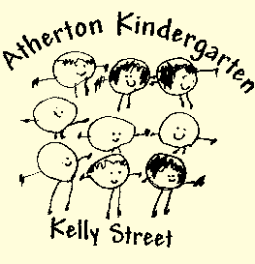
Atherton Community Kindergarten - Waitlist

Child’s name: DOB: Gender:

Parent 1  Name:  Mobile number:  Email address:  Home Address: | Parent 2  Name:  Mobile number:  Email address:
Mailing address (if different from above):

Year of Kindy Commencement:

Has your child been diagnosed with any conditions? E.g. Speech/language issues or delays, allergies, asthma, behavioural issues, ADD/ADHD, diabetes, epilepsy, ASD spectrum disorder or other?

Yes No Seeking support/diagnosis

Please specify:

Parent signature Date:

Office use:

Waitlist received: #

Child’s Name:__________________
Please circle your Kindy session preference:
2 Kindy  days | 3 Kindy days | 4 Kindy days | 5 Kindy days | Traditional Kindy
Mon & Tues  Wed & Thurs  Thurs & Fri | Mon, Tue, & Wed  Wed, Thurs, & Fri  Mon, Tues, Fri | Mon,  Tues, Wed & Thurs  Mon,  Tues, Thurs, & Fri | Mon, Tues, Wed, Thurs, and Fri | Mon, Wed, Fri 8.45am – 2.45pm available 2022  No Holidays  No After Kindy Care
Please circle preferred session times:
8.00am – 3.30pm or 8 .00 am – 6pm

Special Considerations (eg: preferred teacher)
_____________________________________
_____________________________________



