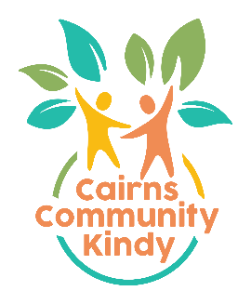

- Our Waiting List is strictly ordered by the receipt date of this Waiting List Form
- Lodgment of this form does not guarantee a place
- Please ensure you keep details up to date with us
- Our enrolment offer process begins in May for the following year of Kindergarten
Cairns Community Kindergarten Inc.
174-178 Gatton Street • Cairns QLD 4870 • PO Box 41, Manunda QLD 4870
Ph 4051 5913 • Email: office@cck.org.au • Web: cairnscommunitykindy.org.au

WAITING LIST FORM

Child’s Name (First Name): (Surname):
Child’s Date of Birth: Male Female
Parent/Guardian Name/s:
Address:
Home Phone: Mobile:
Email Address: ______
Do you have a: Health Care Card Veterans’ Affairs Card Australian Government Concession Card
Do you or your child identify as: Aboriginal Torres Strait Islander South Sea Islander
Aboriginal & Torres Strait Island

Year to Attend – (Please tick)
2022 born 1/7/2017 – 30/6/2018 | 2024 born 1/7/2019 – 30/6/2020 | 2026 born 1/7/2021 – 30/6/2022
2023 born 1/7/2018 – 30/6/2019 | 2025 born 1/7/2020– 30/6/2021 | 2027 born 1/7/2022 – 30/6/2023

Group Preference:
Kookaburra Group Sunbird Group Mon – Tue – Alt Wed Thurs - Fri
8:25am - 2.30pm 8:00am – 3.45pm
Each program offers an average of 15 hours per week.

Please note: Group preferences cannot be guaranteed and our Group days and hours may be subject to change.

Any additional information (special needs, allergies, medical conditions):

How did you hear about us:

Office Use Only
Receipt Date Receipt Number Year

