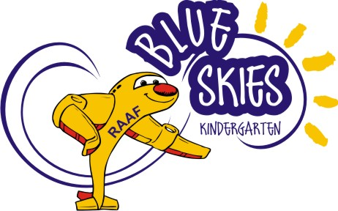

CREATING NEW HORIZONS FOR YOUR CHILDREN

Blue Skies Kindergarten is a community based centre located at
RAAF Base Townsville:-

- Our 4 year old Kindergarten program for children who turn 4 by 30 June in their Kindergarten year;

- Our 4 year old program has 1 group of 22 children and offers a 3 day program;

- The Kindergarten program operates Tuesday to Thursday 8:30am – 3:30pm according to Education Queensland School Terms;

- We employ qualified early childhood staff consisting of a full time teaching Director and full time Teacher’s Assistant;

- At Blue Skies we welcome defence and civilian families;

- Stimulating play environment with unique on-base activities.

- Child-initiated curriculum incorporating Building Waterfalls curriculum and the Early Years Framework which is a joint venture partnership between children, parents and adults;

- Enrolments are now being taken up to and including 2020;

If you would like further information regarding enrolment please contact the centre by phone (07) 4752 1153 or email:- blueskieskindy@gmail.com

